Java environment for Selenium

1. **Install Java**

* Execute jdk-8u152-windows-x64.exe and run through the wizard.
* After completion the installation, create new environment variable ‘JAVA_HOME’ with the value is the installation path.

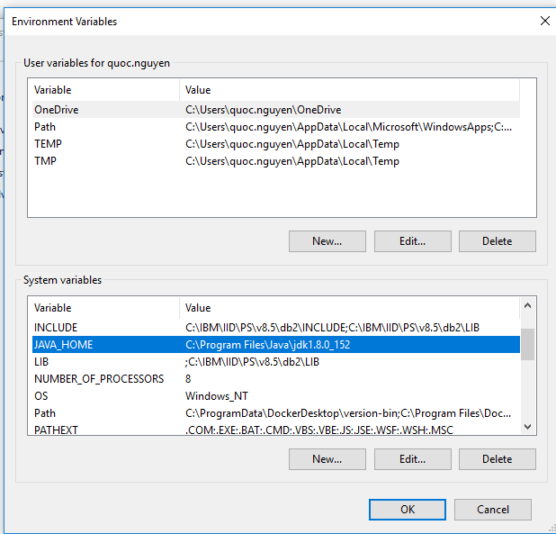

* Add %JAVA_HOME\bin% to Path environment variable

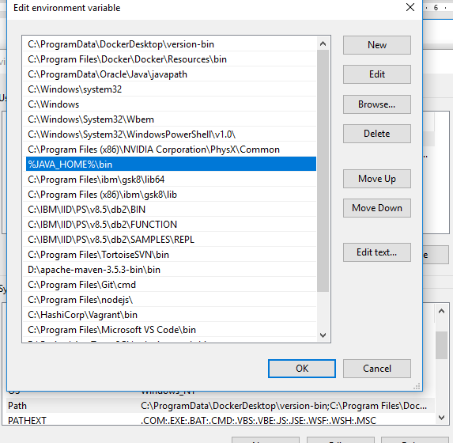

* After those steps, verify java version by running “java -version” in command line. It should work

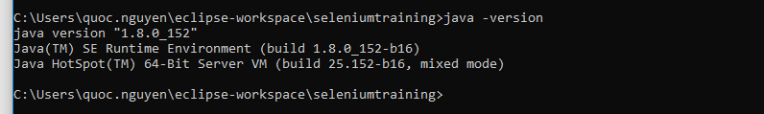

1. **Install Maven**

* Unzip maven file apache-maven-3.5.3-bin.zip into any location
* Add maven path/bin to Path environment variable

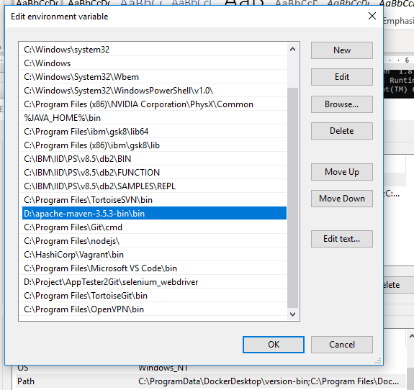

* Verify Maven is worked by running “mvn -version” from command line

